Koronadal Cssssity South Cotabato, 9506



0936 695 5031

**Table of Contents**

Title Page..................................................................................................................... Cover Page................................................................................................................. i

Table of Contents ............................................................................................................... ii

Executive Summary ...........................................................................................................1

**Customer Validation Board ..............................................................................................**

Stage 1 (Problem Validation) ..........................................................................2

Stage 2 (Pitch using Landing Page) ...............................................................3

**Startup Description ............................................................................................................**

Startup Project Name........................................................................................4

Synergy ..............................................................................................................4

Product Type......................................................................................................4

Fire Pitch Video .................................................................................................4

Landing Page.....................................................................................................4

Explainer Video .................................................................................................4

Startup Stage.....................................................................................................5

Product/Service Description .............................................................................7

The Problem ......................................................................................................7

Customer Segments .........................................................................................7

Competitive Advantage.....................................................................................8

Revenue Stream................................................................................................9

Team Description ............................................................................................10

Startup Challenges..........................................................................................11

Roadmap..........................................................................................................12

Purpose ............................................................................................................13

Advantages ......................................................................................................13

Disadvantages.................................................................................................13

Investment Capital...........................................................................................14

Value Proposition Canvas ...............................................................................................16

Competitors Analysis........................................................................................................17

Business Model Canvas ..................................................................................................18

Technology Stack .............................................................................................................19

Storyboard.........................................................................................................................21

Curriculum Vitae ...............................................................................................................27

Course Synthesis..............................................................................................................32

**Executive Summary**

The Water Level Management System is designed to monitor and manage water levels in various environments such as rivers, dams, reservoirs, and other critical water bodies. This system uses advanced sensors and digital technology to provide real-time data on water levels, ensuring timely and accurate monitoring. The primary objective of this system is to enhance public safety, optimize water resource management, and prevent potential flooding or water scarcity issues.  
  
 Our key value proposition is delivering an effective, automated solution for water level management. By providing constant, accurate monitoring, this system supports environmental sustainability and proactive risk management. Regular use of the Water Level Management System aids in maintaining safe water levels, especially during seasonal changes and adverse weather conditions. It can integrate with existing infrastructure to foster a robust water management ecosystem that helps protect communities, reduce environmental impact, and ensure a steady water supply for essential uses.

**Customer Validation Board**

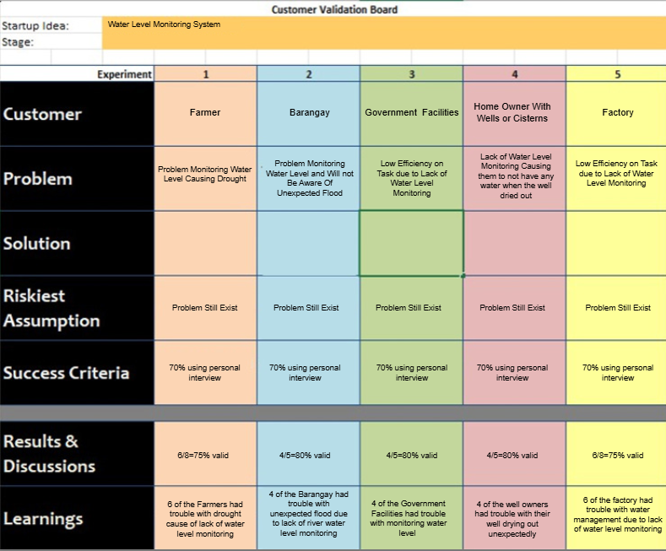

**Stage 1 (Problem Validation)**

***Figure 1.1:*** *Customer Validation Board of FAA: Fish Amino Acid*

**Stage 2 (Pitch using Landing Page)**

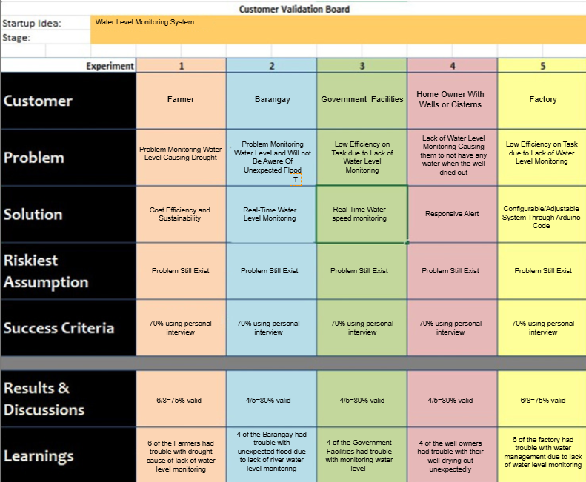

**STARTUP DESCRIPTION**

**Startup Project Name**

Water Level Management System (WLMS)

**Synergy**  
 Bachelor of Science in Information Technology

**Product Type**

**Materials**

**Fire Pitch Video**

**Explainer Video**

• <https://www.youtube.com/watch?v=djwBBN5hKzY>

**Landing Page**

• <https://earldamiles.wixsite.com/fish-amino-acid>

**STARTUP STAGE**

**Phase 1: Idea Generation and Research**

**Research and Development**: Conduct comprehensive research on water level monitoring systems, including sensor technology, data processing methods, and application benefits. Analyze different water bodies such as rivers, dams, and reservoirs to identify specific needs and risks associated with fluctuating water levels. Study existing water management systems and their limitations to define competitive advantages.

**Market Research**: Evaluate market demand, potential customer base (such as government agencies, municipalities, and agricultural sectors), and competitive landscape. Identify unique selling points and determine how the system can stand out in the water management technology market.

**Concept Development**: Design a system that balances accuracy, cost-efficiency, and environmental sustainability, leveraging IoT and real-time data analytics for efficient water monitoring.

**Phase 2: Planning and Development**

**Business Plan**: Develop a business plan with clear objectives, target markets, marketing strategies, financial projections, and operational plans. Assess the required resources, such as high-quality sensors, software, infrastructure, and skilled personnel, to establish and manage the startup.

**Prototype Development**: Create a prototype system that can monitor and relay water levels accurately. Integrate quality control measures for sensor accuracy, data stability, and effective data visualization. Refine the system as necessary to ensure precision and durability in real-world settings.

**Phase 3: Testing and Iteration**

**System Testing**: Conduct field trials in various water bodies to validate the effectiveness of the Water Level Management System. Assess its performance in diverse environmental conditions, recording data on its reliability, response time, and accuracy in detecting water level fluctuations.

**Feedback and Improvement**: Gather feedback from initial users, including engineers, environmental scientists, and local authorities, to identify areas for improvement. Use this information to refine the system’s functionality and enhance its adaptability to different water bodies and use cases.

**Phase 4: Product Launch and User Acquisition**

**Manufacturing and Production**: Establish or source a production facility with the necessary technology and infrastructure to produce the Water Level Management System. Implement strict quality control standards to maintain data accuracy, durability, and compliance with industry norms.

**Marketing and Sales**: Identify key customers, such as municipalities, environmental agencies, and agricultural organizations. Develop sales channels to engage these audiences through direct sales, partnerships, or distributor networks. Develop competitive pricing strategies based on production costs, customer needs, and market demand.

**Phase 5: Scaling and Expansion**

**Market Expansion**: As the system gains traction, explore opportunities to expand into new markets, including flood-prone regions or large agricultural areas. Build strategic partnerships with other technology firms and expand distribution channels to reach a broader audience.

**Scaling Operations**: Increase production capacity to meet growing demand. Optimize supply chain management to ensure reliable delivery and support the scalability of the system for larger projects and expanded geographical coverage.

**Product/Service Description**

The Water Level Management System is an advanced monitoring solution designed to measure and report water levels in real-time for bodies of water such as rivers, dams, reservoirs, and flood-prone areas. Using IoT sensors, data analytics, and cloud-based platforms, the system provides accurate water level measurements that can be accessed remotely. This system can be deployed to monitor critical water level thresholds and send alerts in the event of rising or falling water levels, helping to prevent flooding, manage water resources, and support timely responses to environmental changes.

**The Problem**

**Risk of Flooding**: Without real-time water level monitoring, communities and infrastructure

are at high risk during sudden increases in water levels, especially during heavy rainfall.

**Water Scarcity Management**: Ineffective monitoring can lead to inefficient water resource management, which is crucial in drought-prone or agriculturally dependent regions.

**Infrastructure Damage**: Water level mismanagement can lead to dam overflow or dry reservoirs, risking damage to infrastructure and the surrounding ecosystem.

**Customer Segments**

**Government Agencies**: Agencies responsible for public safety and water resource management benefit from accurate, real-time data to manage flood risks and water supplies.

**Agricultural Companies and Farmers**: Reliable water level data helps agricultural entities manage water usage effectively for irrigation and conserve water during times of scarcity.

**Environmental and Water Management Organizations**: These organizations can use the system to monitor water ecosystems, maintain environmental safety, and support water sustainability projects.

**Competitive Advantage**

The Water Level Management System offers significant advantages over traditional water monitoring methods and existing competitors in the water management sector. Firstly, it provides real-time monitoring with high accuracy, which enables early detection of potentially dangerous water level changes, such as those due to sudden rainfall or river flow variations. This quick response capability enhances public safety and environmental management efforts.

Secondly, the system’s integration of IoT and cloud-based technology allows for remote access and control, making it adaptable for large-scale applications across rivers, dams, and reservoirs. This flexibility means users can receive instant alerts, analyze data trends, and make informed decisions from any location, reducing the need for frequent on-site inspections.

Furthermore, the system is cost-effective and environmentally friendly. By proactively managing water levels and optimizing water resource usage, the system supports sustainability and helps prevent water scarcity and infrastructure damage. Its combination of accuracy, adaptability, remote accessibility, and sustainability make the Water Level Management System a valuable choice for government agencies, farmers, and environmental organizations looking for advanced, reliable water monitoring solutions.

**Revenue Streams**

**Direct Sales**: Revenue generated from selling the Water Level Management System directly to customers, including government agencies, municipalities, and private organizations.

**Bulk Sales**: Offering the system in bulk to distributors or larger organizations, enabling wider distribution and installation across multiple sites, such as river networks, dam clusters, or municipal water management zones.

**Service Contracts and Maintenance**: Establishing long-term contracts for system maintenance, data monitoring, and software updates. These contracts offer stable, recurring revenue while ensuring customers have access to reliable performance, regular support, and timely upgrades.

**Data and Analytics Subscription**: Offering a subscription-based model where customers can access advanced data analytics, historical water level data, and predictive modeling. This recurring revenue stream provides valuable insights and enables proactive water management.

**Team Description**

**Hipster Hustler Hacker Hacker**



|  |  |  |  |
| --- | --- | --- | --- |
| **Angel Sumog-oy** | **Ellen Belenario** | **Kevin Arnaiz** | **Ronel Cabatuan** |
| Responsible for the | Possesses strong | A team member | Responsible for the |
| documentation of the | entrepreneurial skills | that assists and helps | Processing of the |
| product, including | and a deep | with the processing and | product and |
| portfolio, lightning pitch, | understanding of the | development of the | development of the Fish |
| etc. | market. | product | Amino Acid |
|  |  |  | fertilizer/Insecticide, |
|  | Focuses on the |  |  |
|  | presentation of the |  |  |
|  | product |  |  |

**STARTUP CHALLENGES**

The Water Level Management System, a startup in the environmental and infrastructure management industry, faces several challenges as it seeks to establish a foothold in the market.

Firstly, there is significant competition from established water monitoring and management technology providers with well-established customer relationships and distribution networks. This competitive landscape makes it challenging for a new system to gain market share and build brand recognition. Educating potential customers, such as government agencies, agricultural companies, and municipalities, about the advantages of this advanced, real-time water monitoring system is another challenge. Many institutions rely on traditional, less sophisticated monitoring methods, and convincing them to adopt newer technology requires extensive demonstrations of the system's reliability, accuracy, and cost-effectiveness.

Moreover, implementing the Water Level Management System requires sourcing and maintaining a steady supply of high-quality sensors, communication equipment, and cloud-based infrastructure, which can be logistically challenging and expensive. Ensuring a consistent supply chain and data integrity across diverse geographical locations is crucial to the system's success. Any disruptions in the technology supply chain or data connectivity could present significant setbacks.

Lastly, navigating regulatory requirements and obtaining certifications for environmental monitoring technologies can be time-consuming and costly. Compliance with local and international standards for data security, environmental impact, and public safety is essential to establish credibility and trust among customers.

Overcoming these challenges will require strategic planning, innovation, and targeted marketing strategies to position the Water Level Management System as a reliable, advanced, and sustainable solution for water monitoring in various sectors.

**Roadmap**



***Figure 1.2:*** *Roadmap of FAA: Fish Amino Acid*

**Marketing**

**Market Research**: Conduct research to understand the needs of key customer segments, such as municipalities, agricultural sectors, and environmental agencies, to identify how the system can best serve their water monitoring needs.

**Targeted Marketing and Advertising**: Develop targeted campaigns showcasing the benefits of the Water Level Management System for specific applications, such as flood prevention, irrigation management, and water resource conservation.

**Product Differentiation**: Highlight unique features, such as real-time monitoring, remote accessibility, and data analytics capabilities, that set the system apart from traditional water monitoring methods.

**Customer Engagement and Relationship Building**: Build strong relationships with customers through regular communication, demonstrations, and tailored support services to ensure ongoing satisfaction and loyalty.

**Loyalty Programs**: Offer loyalty programs or long-term contract discounts to encourage repeat business, especially for government and agricultural customers who rely on consistent, accurate data.

**Scale**

**Continuous Improvement and Innovation**: Continuously enhance the system’s technology, including sensor accuracy, data processing speed, and data visualization, to keep up with market demand and technological advances.

**Customer Feedback**: Gather feedback from early users to refine and improve the system, ensuring that it meets diverse customer requirements and adapts to different environmental conditions.

**Revenue**

**Bulk and Wholesale Sales**: Sell systems in bulk to distributors, government bodies, and large agricultural entities to increase market reach and overall sales volume.

**Licensing and Partnerships with Other Companies**: Partner with complementary technology companies to integrate the Water Level Management System with other environmental monitoring solutions, generating additional revenue.

**E-commerce and Direct Sales**: Use direct sales channels and online platforms to reach new customers and simplify the purchasing process.

**Value-Added Services**: Offer additional services such as data analytics, predictive modeling, and maintenance packages, providing customers with comprehensive support and insights.

**Technology**

**Digital Platforms and Data Analytics**: Use a cloud-based platform to provide real-time data and advanced analytics, allowing customers to monitor and respond to water level changes proactively.

**Internet of Things (IoT)**: Incorporate IoT sensors and connectivity to enable remote monitoring, data collection, and alert systems across multiple locations.

**Purpose**

The purpose of developing the Water Level Management System is to provide a reliable, real-time monitoring solution for water levels in rivers, dams, reservoirs, and other critical water bodies. The system is designed to enhance public safety, support water resource conservation, and help prevent flooding. By delivering accurate water data, it aids communities, municipalities, and agricultural entities in managing water resources sustainably and effectively.

**Advantages**

**Real-Time Data**: Offers immediate data on water levels, enabling timely interventions in case of rising or falling water levels.

**Remote Monitoring and Accessibility**: Allows users to monitor water levels from any location, enhancing flexibility and efficiency in water management.

**Accuracy and Reliability**: Provides precise, consistent data to help manage water resources more effectively and reduce the risk of natural disasters like flooding.

**Disadvantages**

**Implementation Costs**: The initial setup cost, including purchasing, installing, and maintaining sensors and network infrastructure, can be high, which may limit access for smaller organizations.

**Data Connectivity Challenges**: Ensuring reliable connectivity in remote or rural areas can be challenging, potentially impacting the system’s ability to deliver consistent, real-time data.

**Environmental Impact of Electronics**: The production and disposal of electronic components and sensors could raise environmental concerns. Sustainable practices in manufacturing and recycling would be necessary to minimize this impact.

**Investment Capital**

The initial investment capital of PHP 50,000 will be strategically allocated to essential resources and activities for the Water Level Management System startup.

**Research and Development (30%)**: Thirty percent of the investment capital will be dedicated to research and development, including expenses related to designing, testing, and refining the water level monitoring system. This covers the cost of IoT sensors, software development, and initial system testing.

**Salaries (20%)**: Twenty percent of the capital will go towards salaries to ensure fair and competitive compensation for the team, including engineers, data analysts, and marketing personnel. This will help retain skilled talent critical for the startup’s growth and product quality.

**Manufacturing and Installation (30%)**: Another 30% of the investment will be used for manufacturing and installation, which includes sourcing high-quality sensors, communication devices, and other essential components. This also covers the setup of data transmission networks and cloud infrastructure to ensure the system’s stability and reliability.

**Advertisement and Promotion (10%)**

Ten percent of the funds will be allocated to advertising and promotional efforts, including digital marketing campaigns, promotional materials, and participation in relevant industry events. These activities are designed to build awareness and establish the system as a credible, effective water management solution.

**Reserve/Petty Cash (10%)**: The final 10% will be set aside as a contingency fund for unexpected costs or minor expenses that may arise. This reserve serves as a safety net to ensure financial stability during the startup phase.

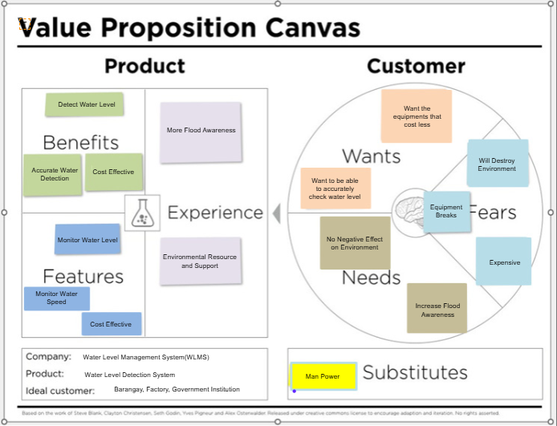

**Value Proposition Canvas**

***Figure 1.3:*** *Value Proposition of FAA: Fish Amino Acid*

**Competitors Analysis**

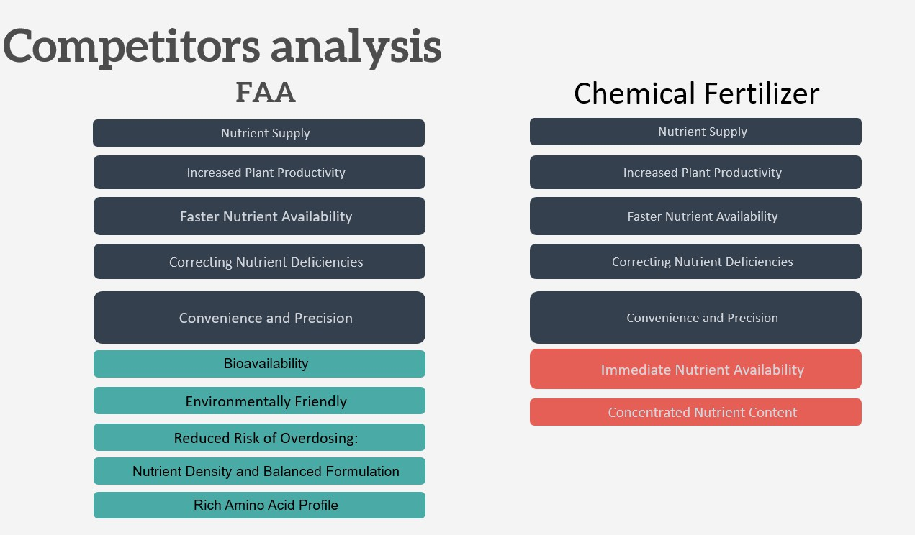

*Figure 1.4: Competitors Analysis of FAA: Fish Amino Acidl*

**Business Model Canvas**

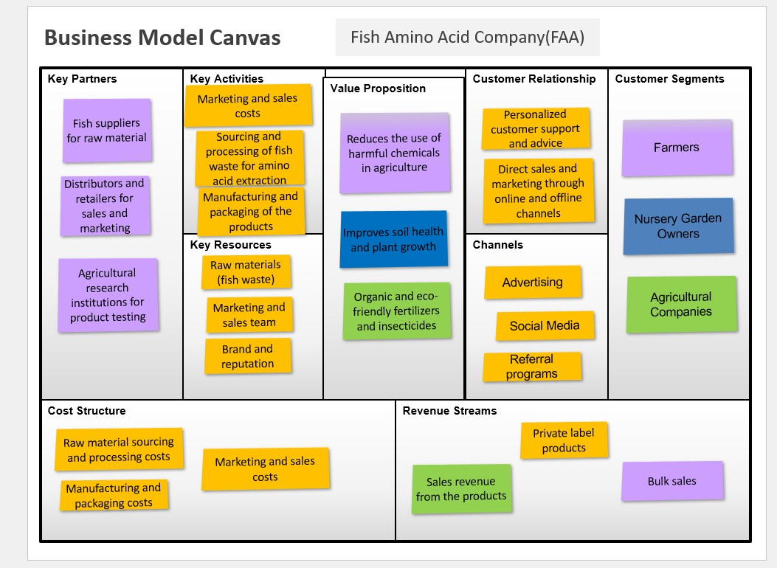

***Figure 1.5:*** *Business Model Canvas of FAA: Fish Amino Acid*

**Technology Stack**

**Product Materials**

Extracting

Fish Waste

Processing

of Fish

Waste

Fermenting

***Figure 1.6:*** *Technology Stack of FAA: Fish Amino Acid*

**System Setup and Installation**

1. **Site Selection and Preparation**  
   Identify strategic locations for sensor installation based on factors such as water flow, depth, and environmental conditions. Sites could include rivers, dams, reservoirs, and flood-prone areas. Ensure that each location provides optimal data collection and minimal interference from external factors like human activity or debris.
2. **Sensor Installation**  
   Install water level sensors at designated locations. These sensors are carefully mounted and calibrated to ensure accuracy. For example, sensors are placed at a certain height or depth to measure changes in water level precisely. Ensure sensors are securely fixed to withstand natural elements and water currents.
3. **Calibration and Testing**  
   After installation, calibrate the sensors to standard water level measurements. Conduct testing to verify that each sensor provides accurate readings and consistent data transmission. Make adjustments as necessary to ensure the reliability of measurements across all sensors.
4. **Data Collection and Transmission**  
   Sensors continuously collect data on water levels, transmitting this information to a centralized cloud-based platform. The data transmission uses cellular networks, satellite links, or other suitable communication methods, depending on the location and connectivity requirements.
5. **Data Processing and Analysis**  
   The collected data is processed and analyzed to monitor real-time water level changes. Advanced analytics and algorithms are used to identify trends, detect anomalies, and trigger alerts if water levels reach critical thresholds. These alerts are sent directly to users, enabling timely interventions.
6. **Maintenance and Monitoring**  
   Conduct routine maintenance on sensors and communication devices to ensure continued accuracy and reliability. Replace or recalibrate sensors as needed to maintain data quality and prevent technical issues.

**STORYBOARD**

Gloves

Rubber Band

Clean

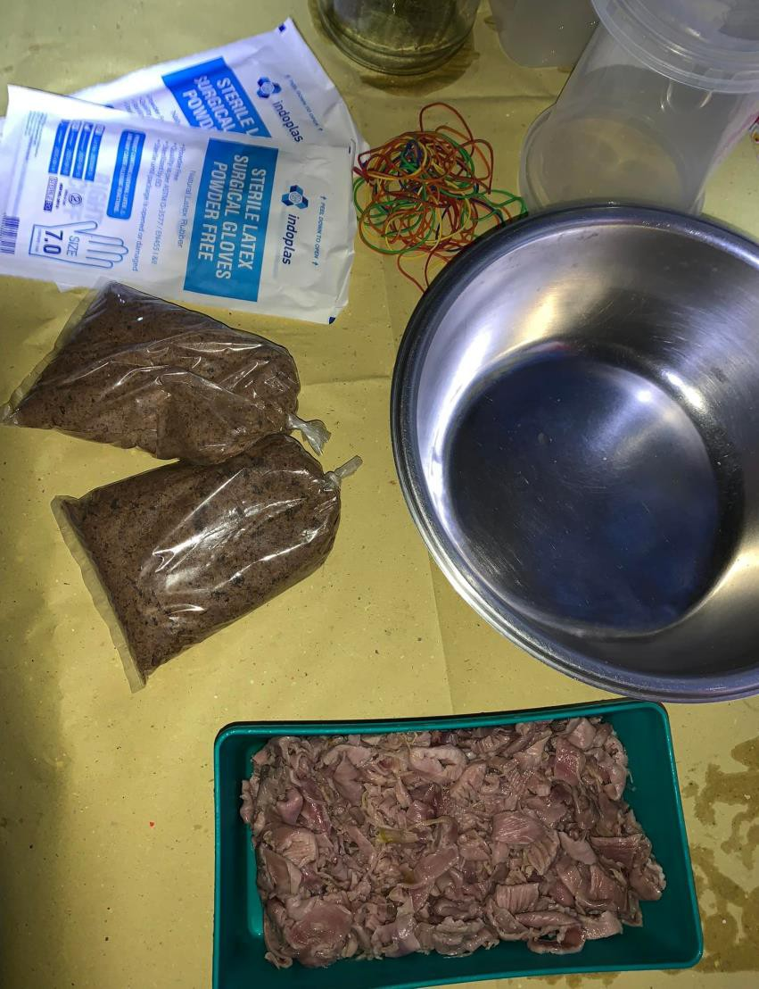

Container

Mascobado

Fish Waste



Put the Fish Waste in a clean Container



Adds sugar and mascobado to create a suitable

environment for fermentation.

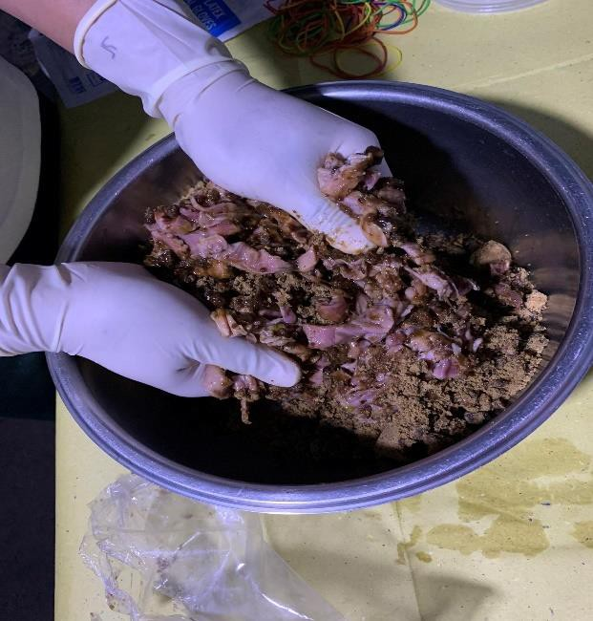

Stir and mix well until the sugar dissolve

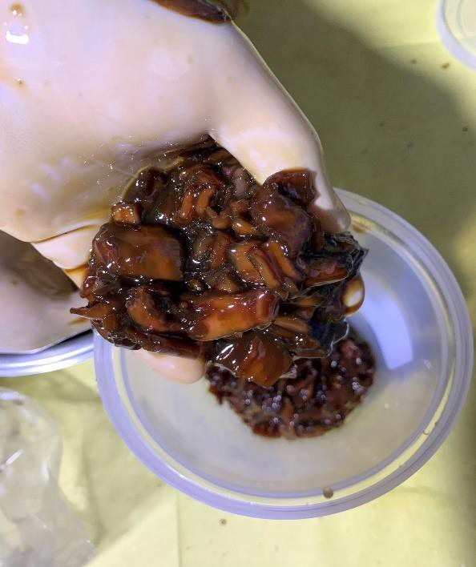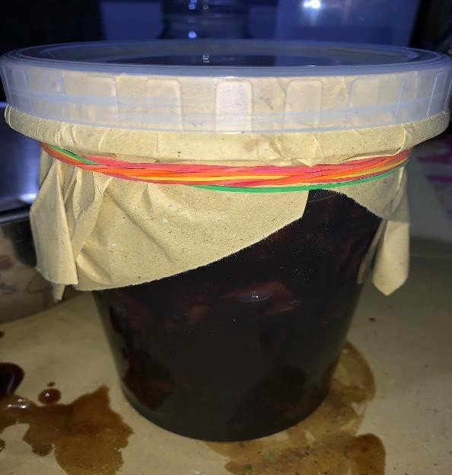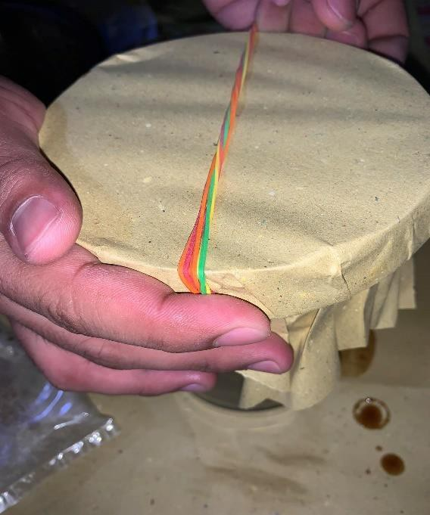

Put it in another container and cover it. Make sure

to cover it well to prevent air from entering

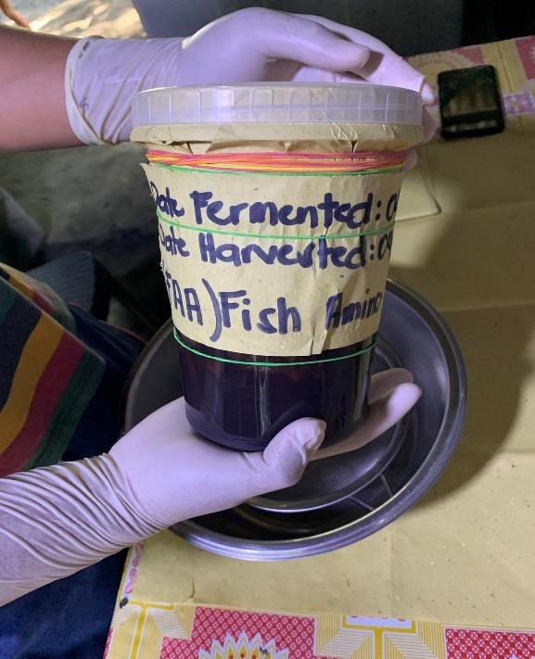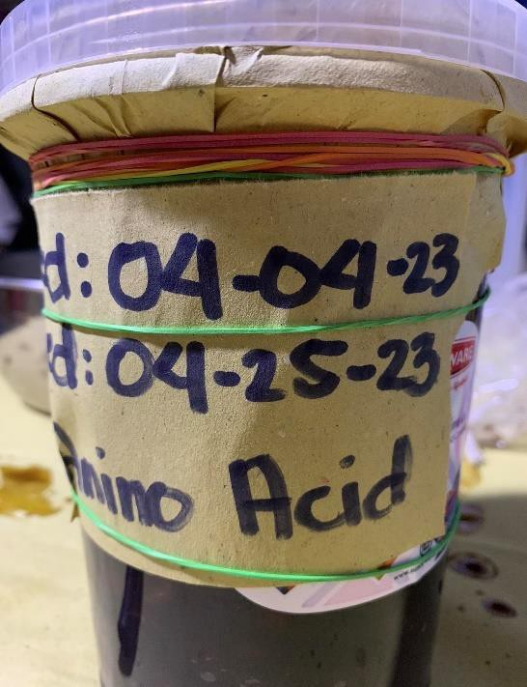

Label the container with the production date and

when to harvest. Fermentation Process will take 2-3 weeks



After fermenting, strains the fermented mixture

using a strainer or a clean cloth

This is the label when mixing the fertilizer in water to

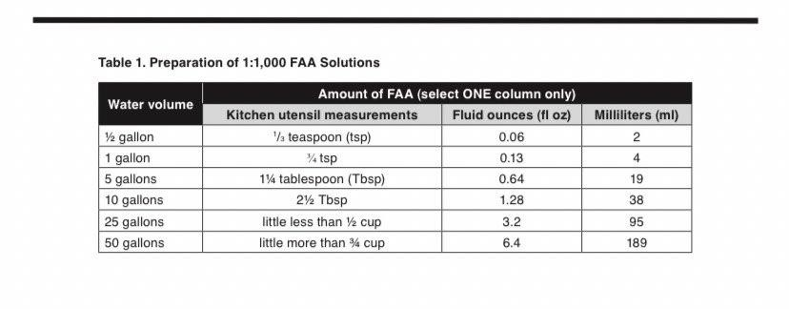

apply in plants

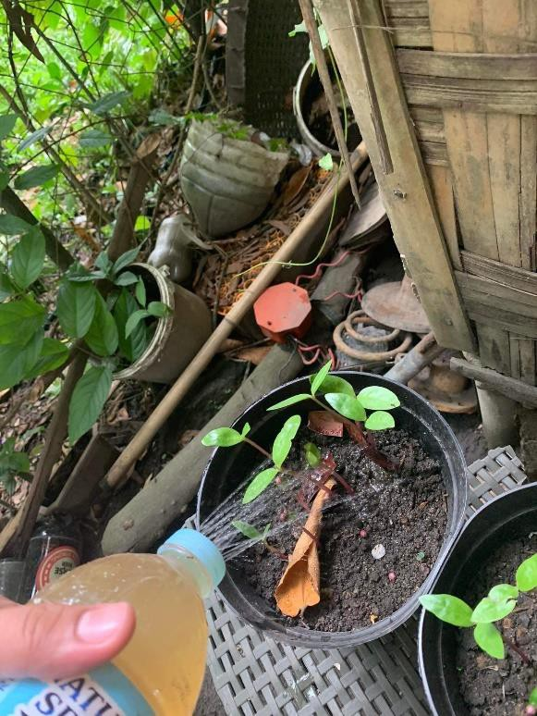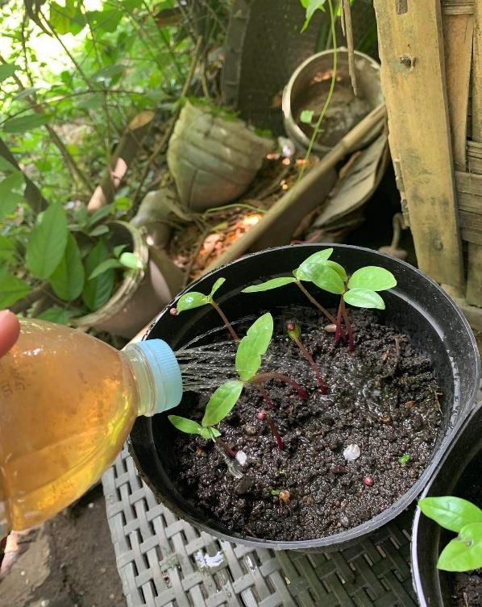

This is when we apply the product in the plants

**CURRICULUM**

**VITAE**

**Summary and Conclusion**

The Water Level Management System aims to provide an innovative solution for real-time monitoring of water levels in rivers, dams, and other critical water bodies. This system is designed to enhance public safety, support water resource management, and mitigate environmental risks by offering accurate, timely water level data. It targets municipalities, government agencies, agricultural organizations, and environmental management bodies, providing a technology-driven alternative to traditional water monitoring methods that combines efficiency, accuracy, and accessibility.

The development process of the Water Level Management System involves multiple phases, including idea generation, research and development, planning, testing, and scaling. The system’s key advantages include its real-time data capabilities, remote monitoring features, and cloud-based analytics platform, which allow users to make informed water management decisions. Despite competition from established water monitoring solutions, this startup is focused on building brand recognition through targeted marketing, partnerships, and continuous system improvement to demonstrate its unique value.

The Water Level Management System presents a crucial innovation for sectors needing precise and responsive water monitoring technology. By providing real-time data and proactive alert systems, the startup supports sustainable and responsible water management practices, particularly important in the context of climate change and water scarcity. Although challenges remain in market competition and ensuring consistent connectivity in remote areas, the Water Level Management System is well-positioned to meet the demand for reliable water monitoring solutions. Successful execution of its marketing, data analysis, and scaling strategies will enable the business to gain traction in the environmental and water resource management markets, contributing to safer and more sustainable water management practices.